 | 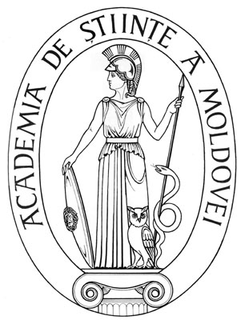 | 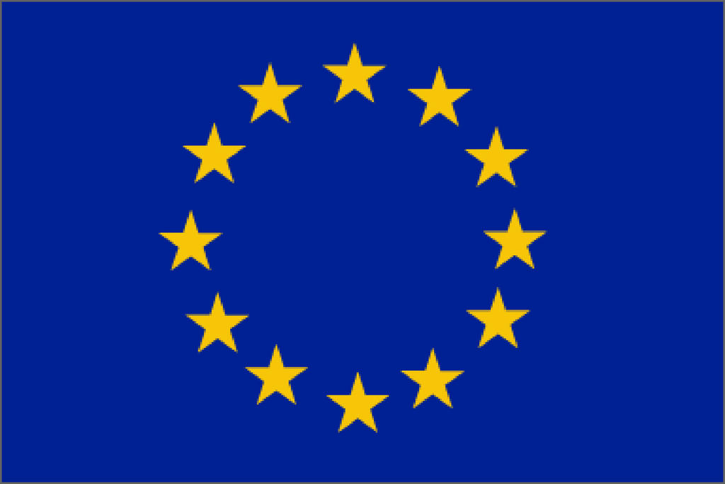

Project “Supporting the implementation of the migration and development component of the EU-Moldova Mobility Partnership” funded by the European Union and implemented by the International Organization for Migration

Call for Proposals – 2010-2011
Temporary return of representatives of the Moldovan Scientific Diaspora

Introduction and Scope

The International Organiztion for Migration, Mission in the Republlic of Moldova (IOM), in partnership with the Academy of Sciences of Moldova (ASM) will support on a competitive basis 30 researchers – members of Moldovan Scietific Diaspora (MSD) willing to come to Moldova for a short-term visit of 7 – 11 days in order to perform research activities at one of R&D institutions or universities of Moldova.

This program is open to researchers originated from Moldova who are currently working abroad at R&D institutions or universities in any field of basic and applied sciences and have work experience there for a period of minimum 3 years.

Project Objective: Improve Moldova's capacity to enhance the development impact of circular migration through temporary return of highly qualified MSD members in the field of R&D.

Opportunities: Through this program, MSD members will have the opportunity to:

- Contribute by knowledge share to the development of R&D sector in Moldova;
- Establish new and renew previous collaborations with their Moldovan counterparts;
- Promote the integration of Moldovan researchers with the international scientific community;
- Strengthen partnership relations with the Moldovan researchers, which might lead to cooperation within international programs such as EU/FP7, SCOPES, NATO Science for Peace Program, ENPI, etc;
- Get involved in the educational process (undergraduate, postgraduate, PhD, etc)
- Share experience with their Moldovan counterparts on how to improve project proposal writing skills;
- Serve as independent experts in the evaluation of national projects, programs, strategies of development, laws, etc;
- Contribute to the development of joint research publications to be published in Moldova and abroad;
- Participate in informational campaigns to raise society’s awareness on brain drain and mechanisms for stemming this process.

The short term visit should be planned during the period September 2010 – December 2011. IOM will provide grantees with financial support to cover international transportation and daily allowances.

Applications to this program must be submitted at least four weeks prior to the intended date of travel and in accordance with the Proposal Submission Timeline below. Grants will be awarded subject to the result of the contest and availability of funds.

This competition is announced in the framework of the initiative titled: „Addressing brain-drain through temporary return of expatriated Moldovan scientists and overseas young researchers to strengthen Moldova as a research & development hub and to promote temporary and permanent return and skill transfer” funded by the European Union and implemented by IOM within the project: “Supporting the implementation of the migration and development component of the EU-Moldova Mobility Partnership”.

About IOM and ASM

The International Organization for Migration (IOM). Established in 1951, IOM is the leading inter-governmental organization in the field of migration and works closely with governmental, intergovernmental and non-governmental partners.

With 127 member states, a further 17 states holding observer status and offices in over 100 countries, IOM is dedicated to promoting humane and orderly migration for the benefit of all. It does so by providing services and advice to governments and migrants.

IOM works to help ensure the orderly and humane management of migration, to promote international cooperation on migration issues, to assist in the search for practical solutions to migration problems and to provide humanitarian assistance to migrants in need, including refugees and internally displaced people.

The IOM Constitution recognizes the link between migration and economic, social and cultural development, as well as to the right of freedom of movement.

The Academy of Sciences of Moldova (ASM) as the sole public agency of national significance in the field of science and innovation is the plenipotentiary coordinator of scientific and innovation activity, the supreme scientific forum of the country and scientific consultant to the public authorities of the Republic of Moldova (RM).
ASM Activity is based on:
- the Code on Science and Innovation of the RM, adopted in July 2004 as a main legal act, which regulates the activities in the area of S&T;
- the Partnership Agreement between the ASM and the Government of the RM, recently approved for the period of 2009-2012, which authorise the ASM to distribute state-designated State funds on a competitive basis as well as to establish the strategic priorities of science development for the 2009-2012.

III. Program Guidelines

- Candidate Eligibility: All applicants must meet the following eligibility criteria:
  - be nationals of the Republic of Moldova;
  - must demonstrate affiliation with an R&D institution or university abroad for the last 3 years;
  - should have some research background in Moldova;
  - must demonstrate that their visit will pursue one or several opportunities listed in Section I;
  - demonstrate sustainability of partnership with their Moldovan counterparts.

Travel must be planned for a period from 7 to 11 days in duration.

Applicant must guarantee the delivery of a report on undertaken project activities within one month upon return from Moldova.

IOM complies with all laws and regulations that apply to the funding procedure for this program. The ASM reserves the right to reject the participation of any individual or institution in this program in case that the applicant does not meet most of the above-mentioned eligibility criteria.

B. Priorities: Among proposals of equal technical merit, IOM and ASM will give priority to proposals submitted by:
- Applicants from highly rated R&D institutions and universities from abroad.
- Applicants presenting a detailed plan of activity to be performed in the Moldovan R&D institution or university during their short term visit and a detailed description of sustainability of collaboration to be developed with their Moldovan counterparts.
- Young scientists and engineers (under 35 years of age).
- Applicants who will demonstrate involvement of their Moldovan counterparts in the development and implementation of the international projects within FP7, SCOPES, NATO, CEI, NSF, ENPI etc.
- Applicants who will bring an impact on science and technology policies development in Moldova (through national programs and proposals evaluation, national science strategies development etc.).

C. Proposal Contents: Each proposal should include all the items listed below, and should not exceed 15 pages including all required forms. The requirements for the Romanian or Russian version are the same. Applications that do not include the following items will not be considered for funding:
- A signed Cover Page (see attached).
- Applicant’s Curriculum Vitae, which should specify his/her full name, date and place of birth, contact address, education and research background, prior and current employment, selected publications (especially publications in peer-reviewed, international, English-language journals), honours received, and educational and professional goals (maximum 3 pages).
- Project summary answering the questions: who, when, where and how will contribute to the collaboration development (1/2 page).
- Plan of activity describing all aspects of the visit.
- A letter or statement from the Moldovan R&D institution or university accepting the applicant’s request to work, and providing a description of facilities offered for the applicant.
- A description of the opportunities of joint participation in international projects within FP7, SCOPES, NATO, CEI, NSF, ENPI etc.
- A description of possible participation in the development of R&D sector in Moldova.
- A description of possible involvement in the research-education-innovation process in Moldova.
- Possible participation in scientific events organized during the period of short-term staying in Moldova.
- Short list of possible outcomes of the visit including sustainability of further collaboration with Moldovan counterparts.

D. Proposal Submission: Complete applications must be received by ASM and OIM by 6:00 PM Chisinau time according to the following timeline:

Nr. | Deadline for Application Submission: | Review Period: | Award Announcement: | For Travel after:
1. | 1 October 2010 | October 2010 | November 2010 | 1 November 2010
2. | 1 November 2010 | November 2010 | December 2010 | 1 December 2010
3. | 1 December 2010 | December 2010 | January 2011 | 1 January 2011
4. | 1 January 2010 | January 2011 | February 2011 | 1 February 2011
5. | 1 February 2010 | February 2011 | March 2011 | 1 March 2011
6. | 1 March 2011 | March 2011 | April 2011 | 1 April 2011
7. | 1 April 2011 | April 2011 | May 2011 | 1 May 2011
8. | 1 May 2011 | May 2011 | June 2011 | 1 June 2011
9. | 1 June 2011 | June 2011 | July 2011 | 1 July 2011
10. | 1 July 2011 | July 2011 | August 2011 | 1 August 2011
11. | 1 August 2011 | August 2011 | September 2011 | 1 September 2011
12 | 1 September 2011 | September 2011 | October 2011 | 1 October 2011

All applicants must submit their proposals to ASM in the following manner:

- One electronic copy of the full proposal in Romanian or Russian.
- The proposal summary (1/2 page) should be also submitted in English.
- Applications must be submitted to the following e-mail address: diaspora@asm.md

ASM and IOM will not accept fax submissions.

No modifications may be made to any item of the proposal once it has been received by ASM and IOM. If necessary, participants may request and receive additional information from ASM or IOM for completing their applications, but only before the final proposal is submitted. ASM and IOM reserve the right to request additional information from applicants if necessary.

E. Review of Proposals: Each proposal will be screened for eligibility and completeness by ASM staff. Proposals will then be submitted to independent experts in order to obtain technical expert review. Expert reviews will be discussed by an Evaluation Committee comprised of representatives of ASM, host institutions and IOM who will make final recommendations.
.

F. Evaluation Criteria: Applications will be evaluated using the following evaluation criteria:
- Record of Accomplishment: Applicant’s professional record, including publications, international collaborations, and grant funding success.
- Knowledge exchange impact: Prominence of the events and activities in the discipline of research and experience exchange impact for Moldovan scientists.
- Management skills demonstration. Possible involvement of the Moldovan scientists in the project development process, international science consortiums, preparation of joint publication, joint scientific events organization, participation in the national projects, programs, strategies and other documents evaluation.
- Sustainability of the visit’s results/outcomes.

IV. Budget Guidelines

Allowable Costs.

- International Transportation: IOM will cover the expenses of international transportation round-trip airfare to and from Moldova. The air tickets will be booked and purchased by IOM and sent by e- mail to successful grantees.

- Per Diem: IOM will cover the per diem (accommodation, local transportation, meals and incidentals expenses) during the period of visit. The amount of per diem will be paid by IOM to successful grantees upon their arrival in Moldova.

The total amount per day will make:

- 195 USD – for grantees staying and working within Chisinau, and
- 118 USD – for grantees staying and working at institutions/organizations outside Chisinau

Costs associated with pre-visit or post-visit meetings and staying in Moldova will be covered by applicant from his/her own expenses.

B. Support from Other Sources. The ASM and IOM strongly encourage cash or in-kind contributions from other institutions in all their activities. All such contributions relevant to this project should be clearly indicated in the space provided in the Application Form.

V. Moldova R&D Institutions

The host R&D Institution should clearly state the correspondence to the following criteria:
1. Relevance of the scientific activity of team/centre/laboratory of R&D host institution or university to the scientific activity of the applicant.
2. Coordination of the action plan between the team/centre/laboratory of R&D institution or university and the applicant.
3. Ability to provide high quality facilities to perform proposed research activity, including access to internet, scientific equipment, scientific library and sources of scientific information and literature, technology transfer opportunity, consulting services etc.
4. Confirmation of the possibility to offer some additional facilities or assistance if there are some specific needs stipulated within the project.

VI. Additional Information

In case any information on the R&D institution or university is required, please address to the representatives of ASM listed in the table below, or consult the ASM webpage at the following address: http://www.asm.md/?go=sectii&new_language=0.
For questions about the proposal submission process, or for further information about this program, please contact the following persons:

Academy of Sciences of Moldova:  MD-2001, Chisinău, bd. Stefan cel Mare 1, of. 433/440  Website: www.asm.md / www.international.asm.md | International Organization for Migration  MD-2001, Chişinău, str. Ciuflea 36/1, of. 14  Website: www.iom.md / www.migratie.md
Dr. Lidia Romanciuc  Director, Center of International Projects  Tel./fax: (+373 22) 270774  E-mail: intprojects@asm.md;  Vitalie Varzari  Senior Specialist , Departament for European Intergration and International Cooperation  Tel./fax: (+373 22) 212547  E-mail:varzari.vitalie@asm.md; | Ludmila Vasilov  Migration and Development Assistant  Tel: (+373 22) 232940 (ext.140)  Fax: (+373 22) 232862  E-mail: lvasilov@iom.int

Cover Page
Applicant Information

Full name (as it appears in passport)
Current position

Organization/Institution name

Complete mailing address
Applicant’s e-mail address |  |  |  | Tel/fax
Highest degree awarded and field of study/research |  |  |  | Year awarded
Citizenship(s) |  |  | Date of birth (month/day/year)
Do you have any research background in Moldova? | Yes No | If “Yes,” please indicate period and institution name
Do you have any experience of participation in international projects? | Yes No | If “Yes,” please provide the acronym(s) of the funding source(s)

Moldovan Host Organization/Institution Information
Full name of organization/institution
Name and scientific degree of the organization/institution director
Address
E-mail |  | Tel/fax
Recipient scientific department/ centre / laboratory
Name and scientific degree of the recipient department head
E-mail |  | Tel/fax

Period of Planned Visit
Total Period | From |  | To
Staying in the R&D Institution | From |  | To
Participation in other scientific events during visit | Dates

Budget
Category | Amount Requested from IOM | Support from non-IOM sources
1) International transportation | Covered directly by IOM
2) Per Diem (195 USD/day – for grantees staying and working within Chisinau, and  118 USD/day – for grantees staying and working outside Chisinau ) | Covered directly by IOM

Total, USD:

Signature- By signing this application, I certify that I meet all the eligibility requirements in this announcement and that all information provided is accurate to the best of my knowledge.
Applicant’s Signature |  | Date

All applications should be typed with 1.5-spacing, point 12-font size, with margins of 2.5 cm (one inch) at the sides and on the top and bottom, with all pages, including forms, numbered consecutively in the upper right corner.

