FOR IMMEDIATE RELEASE
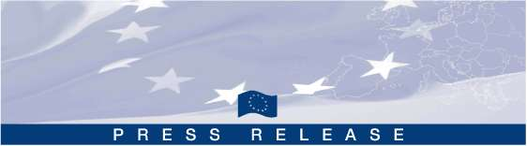
Press Release September 16, 2010
*************************************************************************************
Temporary return of representatives of the Moldovan Scientific Diaspora

Call for Proposal 2010-2011
Orderly and humanely managed migration brings benefits not only to migrants and their families, but also to the entire society

The International Organization for Migration, Mission in the Republic of Moldova (IOM), in partnership with the Academy of Sciences of Moldova (ASM) announces a competition to support 30 researchers on a competitive basis– members of Moldovan Scientific Diaspora (MSD) willing to return to Moldova for a short-term visit of 7 – 11 days in order to perform research activities and share their experience at one of R&D institutions or universities of Moldova.

This competition is open to researchers originating from Moldova who are currently working abroad at R&D institutions or universities in any field of basic and applied sciences and have work experience abroad for a period of minimum 3 years.

Project Objective: Improve Moldova's capacity to enhance the development impact of circular migration through temporary return of highly qualified MSD members in the field of R&D.

The short term visit should be planned during the period October 2010 – December 2011. IOM will provide grantees with financial support to cover international travel and daily allowances.

Applications to this program must be submitted at least four weeks prior to the intended date of travel. The Application Form is placed on: www.asm.md; www.international.asm.md; www.iom.md; www.migratie.md.

This competition is announced in the framework of the initiative titled: „Addressing brain-drain through temporary return of expatriated Moldovan scientists and overseas young researchers to strengthen Moldova as a research & development hub and to promote temporary and permanent return and skill transfer” funded by the European Union and implemented by IOM within the project: “Supporting the implementation of the migration and development component of the EU-Moldova Mobility Partnership”.

*********************************************************************************************
For more information, please contact: Dr. Lidia Romanciuc, Director, Center of International Projects Tel./fax: (+373 22) 270774, e-mail: intprojects@asm.md; or Vitalie Varzari, Main Specialist , Direction for European Integration and International Relations, ASM, tel./fax: (+373 22) 212547, e-mail: varzari.vitalie@asm.md, or Ludmila Vasilov, Migration and Development Assistant, IOM, tel: (+373 22) 232940 (ext.140), fax: (+373 22) 232862, e-mail: lvasilov@iom.int, Web: www.iom.md

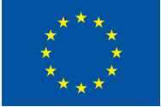 | International Organization  for Migration | 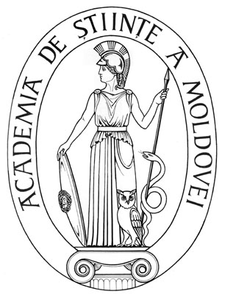
This project is funded by the European Union  Delegation of the European Commission in the Republic of Moldova  12 Kogalniceanu str.,  Chisinau, MD 2001,  Republic of Moldova  Tel: (+373 22) 50 52 10  Fax: (+373 22) 27 26 22  The European Union is made up of 27 Member States who have decided to gradually link together their know-how, resources and destinies. Together, during a period of enlargement of 50 years, they have built a zone of stability, democracy and sustainable development whilst maintaining cultural diversity, tolerance and individual freedoms. The European Union is committed to sharing its achievements and its values with countries and peoples beyond its borders.  The European Commission is the EU's executive body | The project is implemented by the  International Organization for Migration (IOM), Mission to the Republic of Moldova.  36/1, Ciuflea str.  Chisinau MD 2012,  Republic of Moldova  Tel. + 373 22/ 23 29 40;  Fax. + 373 22/ 23 28 62.  E-mail: iomchisinau@iom.int  Web: www.iom.md | The project is implemented in partnership with the Academy of Science of Moldova.  1 Stefan cel Mare bd. Chisinău,, MD-2001  of. 433/440  Website: www.asm.md www.international.asm.md

This publication has been produced with the assistance of the European Union. The contents of this publication are the sole responsibility of International Organization for Migration and can in no way be taken to reflect the views of the European Union.

